JMM
«The Diving Bell and the Butterfly» (2007): The Testimony a Locked-in Man
Eduardo CLAVÉ ARRUABARRENA
Hospital Donostia. Osakidetza. Gipúzkoa (Spain).
Correspondence: Eduardo Clavé Arruabarrena C/ Isabel II, nº 31, 8º D. San Sebastián. 20011. Gipúzkoa. (Spain).
e-mail: eduardocla@telefonica.net Received 9 December 2008; accepted 10 March 2009

Summary
Jean Dominique Bauby suffered from locked-in syndrome after a brainstem injury. He left us a narrative of his convalescence in the
book entitled The Diving Bell and the Butterfly, first published in France in 1997. Based upon this book, Julian Schnabel directed the film of the same title, which provides an account of the evolution of a patient with such a condition. In the film, Jean Dominique asks himself questions about the meaning of life, and shows us the resources he used in order to fuel his will to live: memory and imagination. These resources, along with the love shown to him by his family and friends, became his “beacon” -a symbol of his resilience and hope. The film also addresses the attitudes of health care professionals and of society at large concerning such a dramatic situation.
Keywords: Locked-in syndrome; Narration; Suffering; Imagination; Disability; Living wills.

Technical details
Title: The Diving Bell and the Butterfly
Original title: Le Scaphandre et le Papillon
Country: France and USA

Year: 2007
Director: Julian Schnabel
Music: Paul Cantelon
Photography: Janusz Kaminski
Film editor: Juliette Welfling Screenwriter: Ronald Harwood, based on Jean-Dominique Bauby’s homonymous work.
Cast: Mathieu Amalric, Emmanuelle Seigner, Marie-Josée Croze, Anne Consigny, Patrick Chesnais, Niels Arestrup, Olatz López Garmendia, Jean-Pierre Cassel, Marina Hands, Max von Sydow, Gérard Watkins, Théo Sampaio, Fiorella Campanella, Talina Boyaci and Isaach De Bankolé.
Color: Color
Runtime: 112 minutes
Genre: Biography, Drama Production companies: Pathé Renn Productions, France 3 Cinéma, Kennedy/The Marshall Company, C.R.R.A.V. Nord Pas de Calais, Région Nord-Pas-de-Calais, Canal+, CinéCinéma and Banque Populaire Images 7.
Synopsis: In December 1995, a massive stroke left Jean-Dominique Bauby, a journalist and father of two, in a deep coma. When he awakened he found that all his motor functions had deteriorated. He could not move, talk, or even breathe without help. Only one eyelid of that inert body could be made to move. This eyelid became his link to the world, to others, to life. He would blink once to say yes, twice to say no. With his blinking he would select letters from the alphabet which his visitor would dictate to him, and thus he created words, sentences, whole pages… Awards: Golden Globe for Best Foreign Language Film and Best Director (2007). Nominated for the Oscar to the Best Film, Director, Photography and Screenplay (2007). Best Director Award at the Cannes Festival (2007). http://www.imdb.com/title/tt0401383
It is an ordinary morning. At seven, the chapel’s carillon begins to mark the passage of time again, quarter after quarter. After the night’s truce, my overloaded bronchi start again to echo noisily. My hands, tensed up above the yellowing sheet, make me suffer without me being able to judge whether they are burning or freezing. To fight against ankylosis, I attempt a reflex stretching movement which forces hands and legs to move a few millimetres. This is usually enough to relieve an aching limbª.
J.D. Bauby’s story was successfully made into a film in 2007, harvesting a number of prizes (Figure 1). A few years earlier, the publication of the book¹ in which he recorded his reflections while prostrated in bed or sitting in a wheelchair by means of the blinking of his left eye as the only way of communication, had been an editorial success in France.
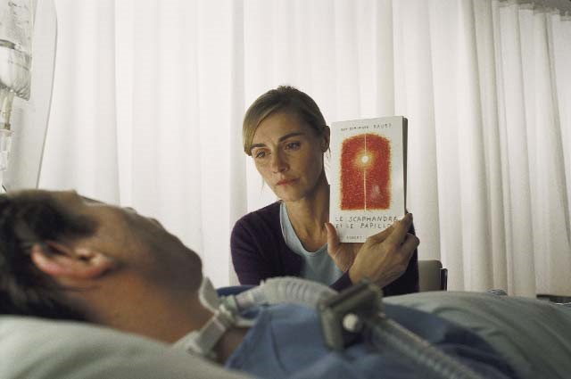
Figure 1: J.D. Bauby’s book was taken to the screens in 2007
When he suffered the stroke that plunged him into a state of severe disability he was working as chief editor for the magazine “Elle” (Figure 2). He was apparently blessed by life and, as is often the case, the illness caught him unawares and left him in a coma. As opposed to other cases, in which the level of consciousness is never completely recovered or leaves serious intellectual sequels that prevent communication with others, the patient began to gain awareness of what had happened to him. He realised that he was completely paralysed and unable to speak a word to express how he felt or what he needed.
The story of a man subjected to one of the most terrifying experiences a human being might live
a.- Le scaphandre et le papillon. P. 10¹.
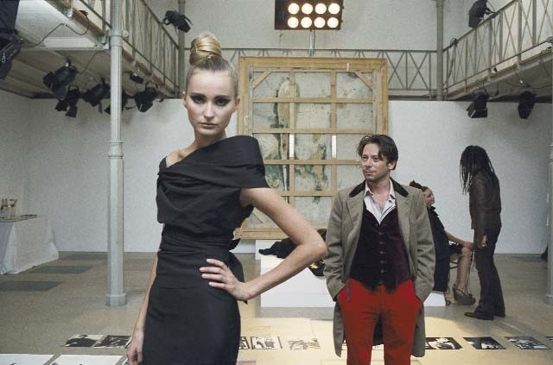
Figure 2: When he had the stroke, Jean-Dominique was chief editor at “Elle” magazine
in a society like ours is reflected in both the film and in the book it is based on. As we can read in the prologue to his book: You survive, but immersed in what AngloSaxon medicine has very justly christened as “locked-in syndrome^{b}: paralysed from head to toe, the patient remains locked within himself, his mind intact and the blinking of his left eye as his only means of communicationª.
In other times, or in less developed societies, the main character would have probably died shortly after suffering the brainstem injury. Advances in technology in developed societies allow human beings to survive, although with serious sequellae whose limitations confront them with really dramatic situations. However, despite these advances in technology and in the resources used to keep such people alive, doctors have neglected to describe such cases in medical journals, with their experiences, their emotions and their suffering, so that professionals might know what to expect from a human point of view. This is one of the reasons why testimonies like Jean Dominique Bauby’s are invaluable.
The awakening of the patient. From darkness into light, or into further darkness?
b.- Locked-in syndrome: a state in which patients have no alteration of consciousness as far as their capacity to connect with their surroundings is concerned, but where they are unable to respond to stimuli (quadriplegia and paralysis of the lower cranial pairs), maintaining only the capacity to move the eyes up and down or blink. This state is generally the result of a brainstem injury, with damage to the corticobulbar and corticospinal tracts that prevents the patient from generating a motor response. Similar symptoms have been described in patients affected by acute polyneuropathy (Guillain-Barré syndrome), acute poliomyelitis and myasthenia gravis². When the injury causes structural alterations to the brainstem, no repair is possible and the neurological sequellae are permanent. The treatment consists of providing care covering all the patient’s basic everyday activities (nutrition, hygiene, mobility, communication and sphincter control), in attempting to avoid infectious complications (pneumonia, urinary, etc.), and treat them as they appear, or those derived from immobility such as pain, stiffness or bed sores, as well as in assisting and relieving the suffering caused by isolation by putting into practice all the available strategies and making use of all the available resources in order to try to communicate with the patient.
The first scenes can be considered splendid and they highlight the great achievement of the film director. They guide the spectator through the eyes of
a bewildered patient who faces confusion and chaos. Blurred images that stem from a lower position (the patient is lying on his bed and his gaze is focused on the walls and ceiling) (Figure 3) and incoherent sentences in a language he can understand, coming from bits of conversations between nurses and auxiliaries who bustle around the room while taking care of the protagonist’s needs. Although the images are dramatic, the film director displays them in a delicate way, showing the spectators the world through Jean Dominique’s eyes, helping them in this way to develop a feeling of empathy. In the first scenes he presents us with professionals who approach the main character with gentleness, even with tenderness, trying to ward off the fear our “forced hero” might be feeling.
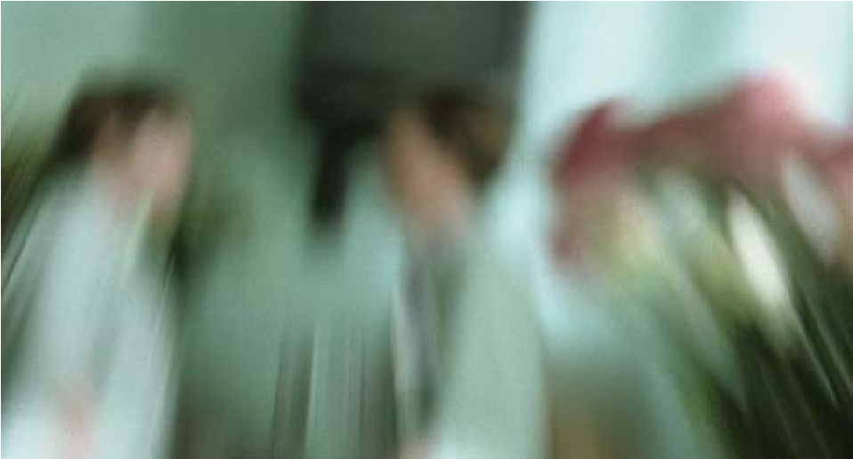
Figure 3: Blurred images from a low angle
Jean Dominique’s first ride in a wheelchair is a revelation (Figure 4). The sight of other patients in wheelchairs as well as that of his own face reflected in a glass display cabinet makes him face the mirror of a reality that he had not been aware of up to that moment. Again, the director tackles the revelation process gently. Everything suggests that the main character will be able to endure a blow that would have been terrible and disheartening for anyone else. The book depicts the impact of that vision on Mr
Bauby: Nobody had sketched an exact picture of my situation, and from gossip gathered here and there, I built up the certainty that it would not take long before I recovered expression and speech… From a simple patient I had become one of the disabled… “You take well to the chair”, the physiotherapist commented with a smile that intended to make her words sound like good news, even if to my ears they sounded like a verdict. I could suddenly glimpse the horrifying reality^{c}.
The gentleness with which the director envelopes the harshness of the situation is his attempt to avoid sentimentalism, and it is one of the character-
c.- Le scaphandre et le papillon. P. 13-15¹.
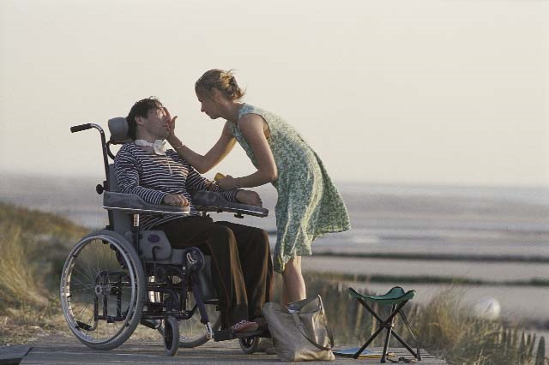
Figure 4: In the wheelchair
istics that define the film. Julian Schnabel tries to remain faithful to the story written by Jean Dominique, which is far from any hint of self-pity. Even the most moving scenes, the ones in which the emotions and suffering of the protagonist can be glimpsed, such as those in which he appears with his father (Figure 5) or with his children, are displayed with the same gentleness, far from cheap sentimentalism, that the protagonist uses in his book. This perception is confirmed by the words of the director himself about the film spoken at its presentation at the 55th San Sebastian Film Festival: “I hate sentimentalism, not feelings. Sentimentalism can kill a work” (Diario de Navarra, Thursday, September 27, 2007).
Another achievement that can be attributed to the film and its director is that of bringing Jean Dominique Bauby’s suffering closer to both the public and health professionals. In fact, a lot of pain remains undiagnosed and unrelieved, among other reasons because contact with something so apparently fearsome
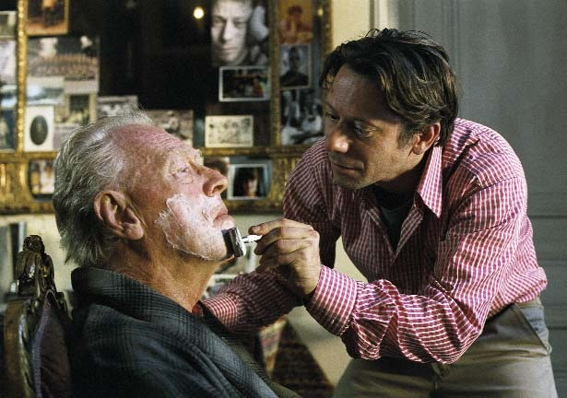
Figure 5: Jean Dominique shaving his father
and difficult to manage as the suffering of others is a risk factor that can lead to avoidance and denial³. In this sense, reading the book and watching the film are a true learning experience for anyone who does not want to be become closeted inside the walls of his/her own convictions. In fact, after learning about such a shocking experience, many people will begin to wonder how somebody can manage to survive in such a state; which resources a human being can count upon to confront such a horrific situation. Throughout the book and the film we learn about some of those resources.
Internal and external resources against despair and suffering

1.- Internal resources: imagination and memory
The pain, loneliness, abandonment, anguish and suffering that the “diving bell”^{d} causes him torment Jean Dominique. His spirit needs a grip, something to keep him alive, something to encourage his wish to remain within a universe that has suddenly and dramatically become so reduced. Going back over his life, the poor man wonders whether it has any meaning: lost opportunities, things left undone, wasted ideas, wasted loves, unspoken sentences, non-declared love, etc. Prostrated on his bed, convalescing from his injury, he discovers what he needs to face a long journey across the desert of isolation and loneliness. He realises that imagination and memory remain untouched and that they are the necessary fuel to drive away his desperation, and that they come to his aid like butterflies: The diving bell becomes less oppressive, and the mind can drift like a butterfly. There is so much to do… One can take flight through space or time, depart for Tierra de Fuego or king Midas’ coast… Or pay a visit to the beloved woman, glide beside her and caress her still sleeping face. Or build castles in the air, capture the Golden Fleece, discover Atlantis, fulfil childhood dreams or adult fantasies^{e}.
Through the world of dreams or memories, or through imagination, Jean Dominique gets rid of his diving bell (Figure 6) and walks along paths where happiness is still possible, keeping the flame of hope alive. Thus, on the south-facing hospital terraces, Jean Dominique Bauby’s imagination takes him to the world of film. He could spend whole days imagining worlds to be discovered and, as he describes in his story, when daytime fades, when it is time to go back to his room… I wait for winter. Well clothed, we will be able to resist until night time, watch the sun go down and the lighthouse take over, shooting rays of hope towards every horizon^{f}.
The lighthouse: symbol of hope and protection.
The ability to communicate and the small improvements which take place throughout his stay in hospital feed his hope for greater achievements, for a possible recovery of language and movement. The lighthouse appears during his “trips” through the Naval Hospital of Berck: It appeared (the lighthouse) at the turn of the staircase that we had taken by mistake: slender, robust and reassuring, with its red and white stripped livery which reminds me of a rugby shirt. I immediately placed myself under the protection of that fraternal symbol that keeps vigil over seamen as well as over the ill, shipwrecks of loneliness^{g}.
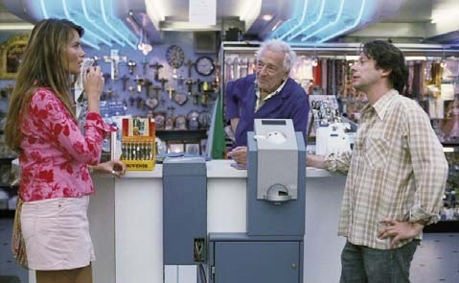
Figure 6: In the dream world, Jean Dominique gets rid of his diving bell

2.- External resources. His family and friends
d.- The diving bell is the term used by Jean Dominique Bauby to refer to a body that does not obey his orders and does nothing but make him suffer. e.- Le scaphandre et le papillon. P. 10-11¹.
f.- Le scaphandre et le papillon. P. 35¹.
g.- Le scaphandre et le papillon. P. 34¹.
Among the factors which cause suffering there are certain ones that are clearly related to abandonment, loneliness, not feeling loved or feeling like a burden for one’s family³. The presence of the mother of his children, his friends and his children is an extremely important support in the convalescence of his illness (Figure 7). Their words, the gentle caresses that provide relief to his inert limbs, offer the strongest support and the greatest strength against an iniquitous fate. … A hint, a shadow, a scrap of dad is still a dad. I feel torn between the joy of watching them live, move, laugh or cry for a few hours and the fear that the display of so many miseries, starting with mine, should not be the ideal distraction for a ten-year-old boy and his little sister of eight, even though as a family we have taken the wise decision not to sweeten anything. … A wave of sadness has overcome me.
Théophile, my son, is sitting there so sweet and serious, his face fifty centimetres from mine, and I, his father, do not even have the right to pass my fingers through his thick hair, to pinch the fuzzy back of his neck, to hug his small smooth and warm body until I embarrass him…^{h}.
Despite the enormous suffering caused by not being able to see or embrace each other, the memory of his father and his voice over the phone allows Bauby to maintain the link of love and affection required to feed his hopes and provide him with another reason to survive. The last time I saw my father I shaved him… We have never seen each other again since then. I do not leave my holiday at Berck and, at ninety-three, his legs no longer allow him to descend the majestic stairs of his building. Each of us is a case of “locked-in syndrome”, each in his own way, I within my flesh wrapping and he on the third floor^{i}.
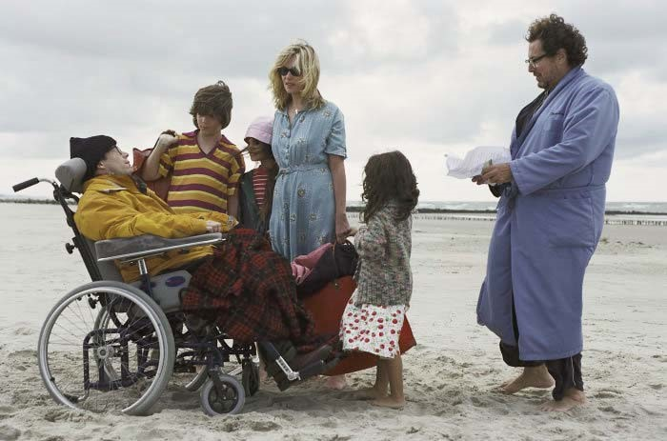
Figure 7: The presence of his the mother of his children, his friends and his own children is an extremely important support in his illness
The importance of letters and phone calls must also be recognised (Figure 8), not only as regards emotional stability and J.D. Bauby’s capacity to face reality, but also with respect to the need he feels to show his humanity, to feel himself to be a human being. I need to feel moved, to love and to admire like the air I breathe. A letter from a friend, a Balthus picture on a postcard, a page of Saint-Simon give meaning to the slow unravelling of time. Nevertheless, to feel alive and in order not to abandon myself to warm resignation, I keep a healthy dose of anger, of ill-temper, neither too much nor too little, like a pressure cooker has a safety valve that prevents it from exploding^{j}.
h.- Le scaphandre et le papillon. P. 76-77¹.
i.- Le scaphandre et le papillon. P. 49-50¹.
j.- Le scaphandre et le papillon. P. 60-61¹.
k.- Le scaphandre et le papillon. P. 19¹.
As far as religious beliefs are concerned, although those who are close to him have attempted to seek the help of different spirits, praying for the craziest things for the sake of his healing - incense, votive offerings from Japan, candles in several Christian chapels, mantras from a Nepali temple, African gods, etc. -, the prayers of his daughter Celeste are the ones that relieve him the most, revealing that what is really important for J.D. Bauby is the love of those who are closest to him: However, such strong protections are nothing but mud fortifications, sand walls, Maginot lines, compared to the small prayer that my daughter Celeste utters every night to her Lord before closing her eyes. Since we fall asleep at the same time more or less, I drift towards dreamland with that wonderful safe-conduct that frees me from any bad encounter^{k}.
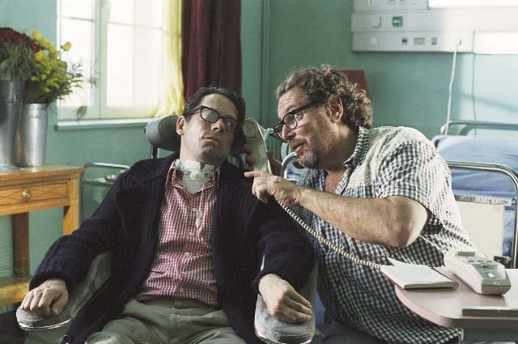
Figure 8: The telephone allows Jean Dominique to maintain a link with loved ones

Health professionals as an example of the “emotionally illiterate”
Julian Schnabel, the film’s director, also criticises the attitude of the health professionals who are in charge of Bauby. And he does so discreetly. The presentation of our “hero’s” experience is so harsh that other aspects of the film, such as an analysis of the health professionals’ behaviour, remain blurred, and only careful scrutiny of the film will unveil enlightening details of aspects that merely increase his suffering. The evasive looks of some of the doctors when they are trying to explain the situation to him; the neurologist’s coldness, far from any form of empathy or pity, when describing his situation; the nurses’ anonymity, reflecting the utter absence of a friendly relationship during his stay at hospital; the ophthalmologist’s lack of respect when he seals his right eyelid (Figure 9), etc. I have known gentler awakenings. When this morning of the end of January I have regained consciousness, a man was leaning over me and he was sewing my right eyelid with cotton and needle like you mend a pair of socks. An irrational fear has overcome me. What if in his enthusiasm as an ophthalmologist he were to sew my left eye too, my only link with the outside, the only skylight in my cell, the window on my diving bell? After carefully arranging his delicate material in tin boxes lined with raw cotton, with the tone of a public prosecutor demanding an exemplary punishment at facing a persistent offender, he limits himself to saying: “Six months”. I multiplied the question signals with my good eye, but the guy, in spite of spending his days scrutinising the pupils of others, could not read looks. He was the typical arrogant, surly and haughty doctor, who at his surgery… As the weeks went by I began to wonder whether the hospital would deliberately turn to such a disgraceful individual with the purpose of catalysing the dull distrust that the medical corps end up arousing in long-stay patients^{l}.
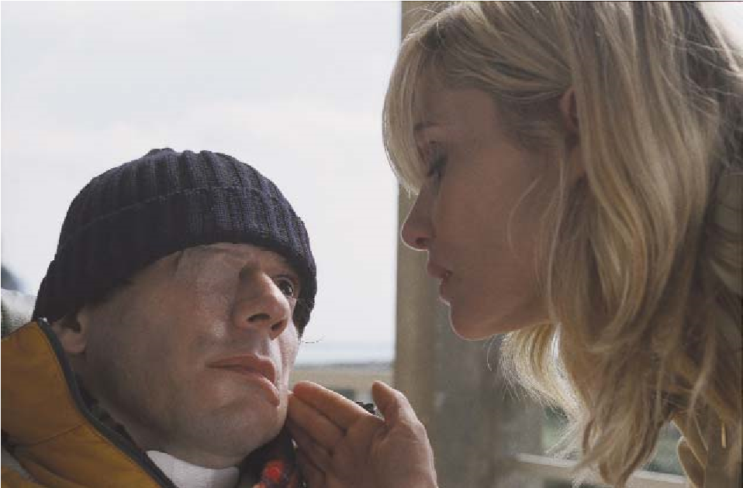
Figure 9: Jean Dominique with his right eye sealed
Even the behaviour of the two people who help him the most and who he most needs - the speech therapist (Figure 10) and the physiotherapistis inadequate. In the case of the former, whom he acknowledges to be in debt to and to whom he is grateful for opening the world of communication with others, gets angry and leaves the bedside when J.D. Bauby says that he wants to die, shouting that his desires are “disrespectful and obscene”, leading our “hero” to take the decision “never to complain again”. For her part, the physiotherapist tramples on his wishes and personal convictions by taking him to Lourdes in search of “a miracle”, thus imposing her religious beliefs on him. In both cases, J.D. Bauby’s autonomy
l.- Le scaphandre et le papillon. P. 59-60¹.
m.- Le scaphandre et le papillon. P. 115-116¹.
is severely coerced and he feels they are staking out a field of play for him that does not match his own and which he has no choice but to put up with.
The film has the courage to show us the difficulties professionals undergo when managing their own emotions and, as a consequence, the impossibility of understanding those of the main character. “Emotional illiteracy” diminishes the capacity to “empathise” with suffering. In this sense, we, as spectators and critics, might think that we would never develop such attitudes. Nevertheless, the film is enlightening and, among the lessons it provides is that of allowing us to discover that our everyday behaviour is not so different from that of the professionals who appear on the screen. As spectators, we feel removed from Jean Dominique’s suffering and, as is the case with our “protagonist” when he sees his reflection in the glass cabinet, reality unravels before our eyes when we see that we too lack the human tact that is required to look after those who need it,… a tact that is crystal clear to those who are ill. … the kind, the brutal, the sensitive, the indifferent, the active, the lazy, those with whom I get on well and those in whose hands I am nothing but another patient. At first some of them inspired terror in me. All I saw in them was the keepers of my prison, the accomplices of an abominable conspiracy. After, I hated others when they twisted one of my arms while sitting me in the chair, they forgot about me and I spent a whole night in front of the television, they left me in a painful position despite my signals of negation. For some minutes or even some hours I would have killed them. And then, since time soothes the coldest of rages, they become familiar beings who better or worse fulfil their delicate tasks: to lighten our crosses a little when they become too heavy for our shoulders^{m}.
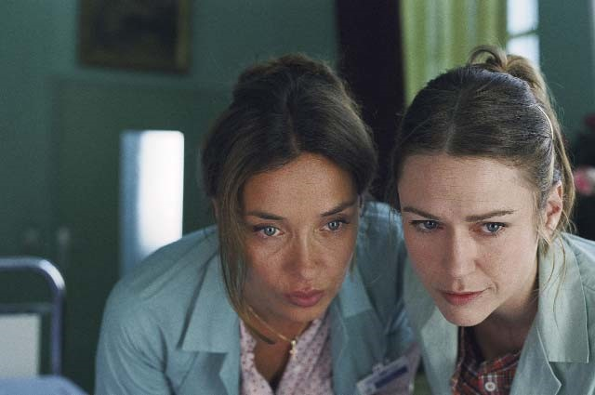
Figure 10: The speech therapist and the physiotherapist are the professionals who helped jean Dominique the most
As Iñigo Marzábal points out, narrative makes us more receptive to others and the reasons for their behaviour and, admitting that the film can have several interpretations (possibly as many as there are spectators) once it has unfolded before our eyes it is possible to discuss the different feelings that the story has aroused in us⁴. Through an analysis of the different types of behaviour depicted in the film, which actually contribute to increasing Jean Dominique’s suffering, we see the possibility of learning that we all require - especially health workers - to improve the care of those who need our attention (Figure 11). What is unquestionable is that Jean Dominique Bauby’s convalescence at the Berck Hospital was a turning point in the life of the health professionals who took care of him, as it might have been for the viewers who have approached the film free of prejudice and eager to understand its accidental protagonist.
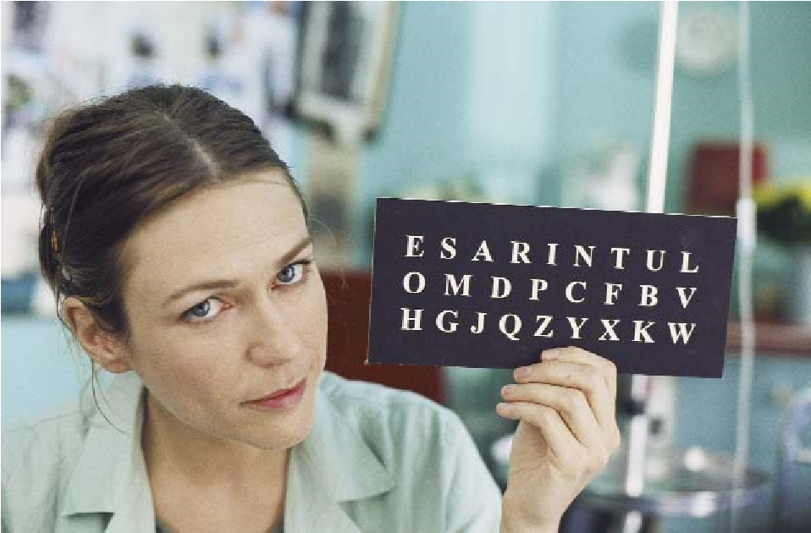
Figure 11: Professionals can learn from this film

Our society and the severely disabled
Another aspect of the film that is worth mentioning is the portrayal of the lonely place where these patients are “parked” while the rest of us continue enraptured with the noise and bustle of our lives. Something similar seems to be the case with Julian Schnabel when in an interview he declared the need to make the film in the hospital where Jean Dominique had been admitted, since he needed to believe in what he heard and read⁵. Patients isolated not only from other living beings, but also from other patients who still retain some hope of re-entering society, patients crammed into old buildings which formerly served other purposes - in the film the Berck hospital that was formerly devoted to the care of children with tuberculosis - as a result of modern technology and
n.- Le scaphandre et le papillon. P. 105-107¹.
medical advances they have been resuscitated to serve new purposes. The purpose of caring for the “new dispossessed” of our society by keeping them out of sight; banishing one of the consequences of our progress from public view; stopping us from wondering about the meaning of our existence, assuaging our conscience and allowing us to flee from a reality that we are prepared to accept only because we turn a blind eye. The goal of taking care of these “nouveaudésavouées” by our society by keeping them out of our sight; that of banishing one of the consequences of our progress from public view; that of stopping us from wondering about the meaning of our existence, that of assuaging our conscience, allowing us to flee from a reality that we are prepared to accept through our blindness. It is Sunday. A spine-chilling Sunday on which, if unfortunately no visitors have announced their arrival, no kind of event will come to alter the languid passage of the hours. Not the physiotherapist, nor the speech-therapist, nor the psychologist. A desert crossing with a brief wash, even quicker than usual, like a single oasis… It is Sunday. If you ask them to turn on the television you have only got one chance. There is a chance that three or four hours will go by before the good soul that can change the channel comes back… It is Sunday. The bell tolls the hours with dignity. On the wall, the National Health Service calendar whose pages are torn out day after day already marks August. By the work of what paradox of time, which here remains motionless, does it flash by outside?^{n}.
Even though Julian Schnabel himself might not have wanted to reflect such marginalization, or perhaps had not even stopped to think about it, the setting of these disabled patients in an institution at some distance from the Parisian capital is a true reflection of our society’s attitude towards them (Figure 12). The situation is similar in Spain, some buildings being used that were formerly dedicated to the care of tuberculosis patients, or institutions that have been refurbished for the care of the disabled.

Epilogue
New projects come to Mr Bauby’s mind when pneumonia -the faithful companion of the neurologically injured- becomes the scythe that cuts them off. His experience, his story, affords us the opportunity to reflect, to wonder about the meaning of our existence, to improve as human beings and as professionals. Each of us must try to find our own answer to J.D. Bauby’s situation so that we can free ourselves from anguish. Perhaps his experience will remain
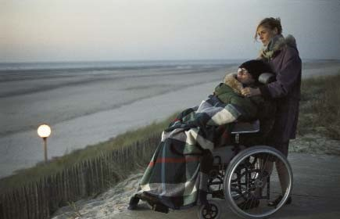
Figure 12: These patients are “parked” in remote places
within us, or it might serve as a model for us to ponder what we would like our representatives to do if we were unable to express ourselves, and what opinions or thoughts we would wish to be reflected in our
Living Wills^{ñ}. Are there in the cosmos keys that can open my diving bell? An underground line without a last stop? A coin strong enough to buy my freedom? I must search elsewhere. Here I goº.

Acknowledgements
The Editors would like to thank the translation team of the Languages Service of the University of Salamanca for their collaboration in the English version of this Journal.

References
Baouby JD. Le scaphandre et le papillon. Paris: Robert Laffont; 1997

Valero i Castell R., Manyalich i Vidal M. Coma y muerte encefálica. Donación de órganos. In Rodés Teixidor J. Guardia Massó J. editors. Medicina Interna. Barcelona: Masson; 1997. p. 291-300.

Hoy cinema [Internet]. Vocento; 2007 Sep 27; [cited 2008 Oct 17]. Festival Internacional de Cine de San Sebastián. 55 Edición. Julian Schnabel presentó “la escafandra y la mariposa”, film “sin sentimentalismo”; [about 2 p]. Available from: http://www.hoycinema.com/especial/sansebastianfestival2007/actualidad32.asp

Clavé E. Casado Da Rocha A. Altoaguirre C. Sufrimiento insoportable y voluntad de vivir: primeros resultados de un estudio en Gipuzkoa. Pal Med (Madrid). 2006; 13(4): 197-206.

Marzábal I. Deliberaciones poéticas. Cine ética y narrativa. Bilbao: Universidad del País Vasco. Servicio Editorial; 2004. p. 31.

decine21.com [Internet]. Madrid: ESTRENOS 21; 2008 Jan 31; [cited 2008 Oct 17]. Hochet R. Entrevistas Julian Schnabel; [about 5 p.]. Available from: http://www.decine21.com/Entrevistas/Julian-Schnabel-31012008.asp?Id=218

ñ.- This is a written document intended for the doctor in charge in which an individual of legal age, who has not been prevented from doing so by law, freely and in compliance with legal requirements expresses the instructions to be taken into account when that person is in a situation that does not allow him or her to express his or her will personally. In the document, the individual may appoint one or several representatives to become the interlocutors with the doctor or medical team, and take the necessary decisions if the person in question is unable to The possibility of the representative taking part in the drafting of the document is recommended so that it can faithfully represent the desires of the patient when he/she cannot express them personally. o.- Le scaphandre et le papillon. Last page p. 137¹.

