eISSN 2444-7986
DOI: https://doi.org/10.14201/orl201784.15783

Case report

MEDIASTINAL PARAGANGLIOMA DETECTED BY ¹¹¹IN-PENTETREOTIDE SCINTIGRAPHY AND SPECT/CT. A CASE REPORT

Paraganglioma mediastínico detectado con gammagrafía SPECT-TC con ¹¹¹In-pentetreótida. Descripción de un caso

Luis Gonzaga DÍAZ-GONZÁLEZ¹, Berta PÉREZ-LÓPEZ¹, Yoana FRANCO-RODRÍGUEZ², Ángel MUÑOZ-HERRERA³, Pilar TAMAYO-ALONSO^{1,4}

Hospital Universitario de Salamanca. ¹Nuclear Medicine Department. ²Pathology Department. ³Otorhynolaringology Department. ⁴IBSAL (Salamanca Institute of Biomedical Research). Salamanca. Spain.

Correspondence: ludiagon@hotmail.com

Reception date: February 22, 2017
Date of Acceptance: March 11, 2017
Publication date: March 26, 2017
Date of publication of the issue: December 1, 2017

Conflict of interest: The authors declare no conflicts of interest
Images: The authors declare that the images have been obtained with the permission of the patients
Rights policy and self-archive: the self-archive of the post-print version (SHERPA / RoMEO) is allowed
License CC BY-NC-ND. Creative Commons Attribution-Noncommercial-NoDerivate Works 4.0 International
University of Salamanca. Its commercialization is subject to the permission of the publisher

SUMMARY | Introduction: Mediastinal paragangliomas are low incidence tumors that arise from neural crest. Its diferential diagnosis include several malignant diseases, so its correct characterization is mandatory for an adecuate therapeutic management. ¹¹¹In-Pentetreotide scintigraphy/SPECT-CT can detect paraganglioma, mainly in those cases of atypical or unsuspected location, and may have a significant role in follow-up of those patients diagnosed with multifocal and familiar paraganglioma. Case: Here we report a case of an extremely rare middle mediastinal paraganglioma, detected by scintigraphy and SPECT-CT with ¹¹¹In-Pentetreotide in a patient diagnosed of multifocal and family history of paraganglioma. Surgery was carried out by median sternotomy and extracorporeal circulation. The pathological examination of the surgical specimen showed a para-aortic low-grade tumor, positive for chromogranin and synaptophysin, cytokeratin AE1-AE3 negative and Ki67 lower than 5%, compatible with paraganglioma. Currently, the patient is tumor free, under clinical monitoring. Conclusions: 111In- Pentetreotide scan proved to be a helpful diagnostic method because of its potential to explore full body, so It allows us to locate unsuspected and atypical location paragangliomas. This finding suggests that patients diagnosed with multifocal head and neck paraganglioma should undergo periodical follow-up with 111In-Pentetreotide scan to detect unsuspected paraganglioma.
KEYWORDS | mediastinal paraganglioma; ¹¹¹In-Pentetreotide scintigraphy; chemodectomas
RESUMEN | Introducción: Los paragangliomas mediastínicos son tumores de baja incidencia que surgen de la cresta neural. Su diagnóstico diferencial incluye varias enfermedades malignas, por lo que su correcta caracterización es obligatoria para un adecuado tratamiento. La gammagrafía SPECT-CT con ¹¹¹In-pentetreótida puede detectar paragangliomas, principalmente en aquellos casos de localización atípica o no sospechada, y puede tener un papel significativo en el seguimiento de los pacientes diagnosticados con paraganglioma multifocal y familiar. Caso clínico: Se presenta un caso de un paraganglioma mediastínico medio extremadamente raro, detectado por gammagrafía y SPECT-CT con ¹¹¹In-pentetreótida en un paciente diagnosticado de historia multifocal y familiar de paraganglioma. La cirugía se realizó mediante esternotomía media y circulación extracorpórea. El examen patológico de la muestra quirúrgica mostró un tumor paraórtico de bajo grado, positivo para cromogranina y sinaptofisina, citoqueratina AE1-AE3 negativo y Ki67 menor de 5%, compatible con paraganglioma. Actualmente, el paciente está libre de tumores, bajo supervisión clínica. Conclusiones: La exploración con ¹¹¹In-pentetreótida demostró ser un método de diagnóstico útil debido a su potencial para explorar todo el cuerpo, por lo que permite localizar paragangliomas insospechados y de localización atípica. Este hallazgo sugiere que los pacientes diagnosticados con paraganglioma multifocal de cabeza y cuello deben someterse a un seguimiento periódico con ¹¹¹In-pentetreótida para detectar paraganglioma no sospechado.
PALABRAS CLAVE | paraganglioma mediastínico; ¹¹¹In-pentetreótida; quemodectoma

INTRODUCTION
Paragangliomas are low incidence neuroendocrine tumors that express somatostatin receptors, being type 2 the most common of them [1, 2]. They arise from the neural crest of the autonomic nervous system and are usually benign slow growing lesions, which can produce compressive clinic or neurological dysfunction due to an involvement of adjacent nerves. Its most common location is head and neck, being the carotid glomus or carotid chemodectomas the most frequent of all its forms [3, 4].
Diagnosis is based on structural imaging tests such as magnetic resonance imaging (MRI), computed tomography (CT) or angiography and functional imaging tests, as ¹¹¹In-Pentetreotide scintigraphy. One of the main diagnostic indications of Nuclear Medicine tests is the suspicion of paragangliomas in areas of difficult biopsy access and/or in cases of atypical locations, which require differential diagnoses with other pathologies [1].
Here we report a case of an extremely rare middle mediastinal paraganglioma, detected by scintigraphy and SPECT-CT with ¹¹¹In-Pentetreotide in a patient diagnosed of multifocal and family history of paraganglioma.

CASE
A 54-year-old male was diagnosed in 1997 of family and multifocal paraganglioma (bilateral carotid and right jugular tympanic paraganglioma). He underwent surgery and all paragangliomas were excissed. Afterward, he stayed asymptomatic with no evidence of residual disease or recurrence by structural techniques and octreotide and being discharged in 2005. In 2013, he returns to our Hospital for a follow-up consultation.

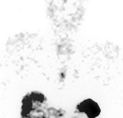
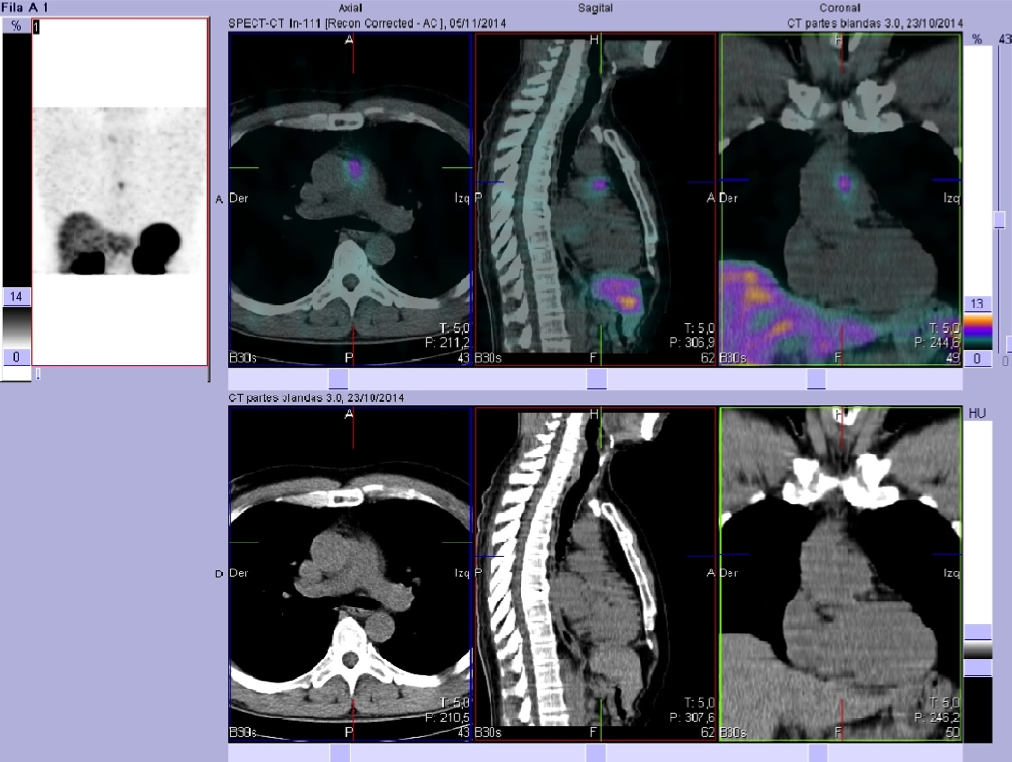
Figure 1. Aortic paraganglioma. ¹¹¹In-Pentetreotide planar scintigraphy and SPECT-CT images show weak focal uptake in mediastinum, adjacent to ascendant Aorta. Histologic study was recommended.
Otoscopy and analytical study showed no abnormalities and ¹¹¹In-Pentetreotide scintigraphy was requested to evaluate rest or recurrence of paraganglioma. The study showed weak uptake in the left jugular region, what led to the suspicion of tumor recurrence, and a review was scheduled within a year.
New scintigraphic control was performed in October 2014, showing the previously described weak focal uptake and the appearance of a new focus in the anterior mediastinum (Figure 1).
Thoracic SPECT-CT fusion images located the mediastinal focus adjacent to aorta and pulmonary trunk (Figure 1). Given this finding, contrast enhanced CT scan and an angiography were performed. CT scan reported a nodule of 15 x 18 mm in aortopulmonary window, adjacent to the aortic root, in contact with the left coronary sinus.
The angiography showed nodule irrigation by septal coronary branch. No MRI was performed because of multiple ferromagnetic plates in both lower limbs, due to an accident suffered by the patient 20 years ago.
Given these findings, surgical treatment of the mediastinal lesion was planned. Surgery was carried out by median sternotomy and extracorporeal circulation. The pathological examination of the surgical specimen showed a para-aortic low-grade tumor, positive for chromogranin and synaptophysin, cytokeratin AE1-AE3 negative and Ki67 lower than 5%, compatible with paraganglioma (Figure 2). Currently, the patient is tumor free, under clinical monitoring.

DISCUSSION
Mediastinal paragangliomas are extremely rare. They are most commonly located in the posterior mediastinum, with its origin in paraspinal ganglia, while those located in the middle mediastinum arise from the para-aortic lymph node chains. Its low-frequency forces to establish a differential diagnosis with other pathologies such as thymoma, thymic carcinoma, metastases or angiosarcoma. However, these pathologies do not express somatostatin receptors, so ¹¹¹In-Pentetreotide scintigraphy exclude them [5, 6, 7].
The first line diagnosis of paraganglioma is the study of biochemical parameters and structural imaging tests (CT, MRI). Scintigraphy and SPECT/CT with ¹¹¹In-Pentetreotide have good levels of sensitivity (93%) and specificity (86,5%) for the detection of head and neck paragangliomas [3, 7, 8]. FDG PET studies are especially useful in cases with negative scintigraphy and positive mutation for succinate dehydrogenase gene (SDHX) [9]. In this case, the patient showed negative biochemical tests and SPECT/CT with ¹¹¹In-Pentetreotide identified the para-aortic lesion accurately, allowing its proper surgical excision.

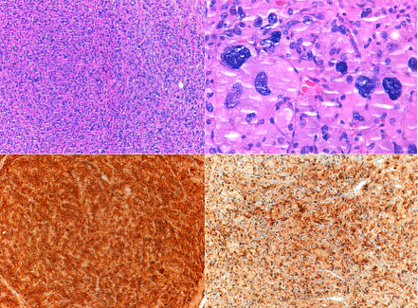
Figure 2. Its histology consists of two main celular types: epitelial (3A) and peripherical sustentacular cells; Both involved in a highly vascularized stroma. The presence of citological atypia and celular pleomorfism (3B) are not a sign of agressiveness, as this is determined by the presence of necrosis, mitosis and capsular invasión. Its inmunohistochemical features are: Sinaptophisine/cromogranin positive (major cells) (3C) and s-100 sustentacular cells (3D) with a low (Ki-67) proliferation index. Citocheratin (actin and desmin) expression were negative. Those findings lead us to the diagnosis of aortic paraganglioma [10].

In conclusion, we report the case of a 54 years old male with multifocal and family history of paraganglioma 17 years ago, who currently presented an extremely rare asymptomatic middle mediastinal paraganglioma, diagnosed by planar and SPECT/CT with ¹¹¹In- Pentetreotide scan.

This procedure proved to be a helpful diagnostic method because of its potential to explore full body, so It allows us to locate unsuspected and atypical location paragangliomas. This finding suggests that patients diagnosed with multifocal head and neck paraganglioma should undergo periodical follow-up with ¹¹¹In-Pentetreotide scan to detect unsuspected paraganglioma.

REFERENCES
- Castillo-Berrio C, Castrillón M, Zelaya F, Ruíz D, Loira F, Nogueiras JM, et al. (111)In-octreotide SPECT-CT in head and neck paragangliomas. Rev Esp Med Nucl Imagen Mol. 2015;34(5):321-4.
- Schmidt M, Fischer E, Dietlein M, Michel O, Weber K, Moka D, et al. Clinical value of somatostatin receptor imaging in patients with suspected head and neck paragangliomas. Eur J Nucl Med Mol Imaging. 2002;29(12):1571-80.
- Tamayo P, Ruano R, Muñoz A. Diagnóstico y control evolutivo de los paragangliomas de cabeza y cuello. Aportaciones de la medicina nuclear. Acta Otorrinolaringol Esp. 2009;60:68–75.
- Feijoo Cano C, Carranza Martinez JM, Rivera Rodríguez MI, Vázquez Berges I, Herrando Medrano M, Marco Luque MA. Tumores del cuerpo carotídeo. Experiencia en 22 años y protocolo de seguimiento y despistaje familiar. Angiologia. 2012;64:155–60.
- Bano G, Sennik D, Kenchaiah M, Kyaw Y, Snape K, Tripathi V, et al. A case of co-existing paraganglioma and thymoma. Springerplus. 2015;21(4):632.
- Mehta CK, Gillespie CT, Lin X, Yeldandi A, DeCamp M, Bharat A. Rare Middle Mediastinal Paraganglioma Mimicking Metastatic Neuroendocrine Tumor. Ann Thorac Surg. 2015;100(2):702-5.
- Shibahara J, Goto A, Niki T, Tanaka M, Nakajima J, Fukayama M. Primary pulmonary paraganglioma: report of a functioning case with inmunohistochemical and ultrastructural study. Am J Surg Pathol 2004;28:825-9.
- Bustillo A, Telischi F, Weed D, Civantos F, Angeli S, Serafini A, et al. Octreotide scintigraphy in the head and neck. Laryngoscope. 2004; 114: 434-40.
- Därr R, Lenders JW, Hofbauer LC, Naumann B, Bornstein SR, Eisenhofer G. Pheochromocytoma-update on disease management. Ther Adv Endocrinol Metab. 2012;3:11-26.
- Travis WD, Brambilla E, Burke AP, Marx A, Nicholson AG (Eds.). WHO Classification of Tumors of the Lung, Pleura, Thymus and Heart. IARC: Lyon, 2015.

