eISSN 2444-7986
DOI: https://doi.org/10.14201/orlxxxxxxxx

Artículo original / Caso clínico / Artículo de revisión

Título del artículo en español (minúscula 14p)

Title-English cursiva en redonda (minúscula 14p)
Multidimensional assessment of voice quality of future elite vocal performers

Nombre (redonda) y APELLIDOS (mayúsculas separados por guión) de cada autor separados por punto y coma (10p)
Authors: Mureşan RODICA-ELENA; Pop ALEXANDRA-SABINA (Romania)

Institución(es) de los autores cursiva (8p)
ENT Clinic, County Clinical Emergency Hospital, Cluj-Napoca, Romania

Correspondencia: rdcmuresan@yahoo.com; marc_alexandra@yahoo.com

Fecha de recepción:
Fecha de aceptación:
Fecha de publicación:
Fecha de publicación del fascículo:

Conflicto de intereses: Los autores declaran no tener conflictos de intereses
Imágenes: Los autores declaran haber obtenido las imágenes con el permiso de los pacientes
Política de derechos y autoarchivo: se permite el autoarchivo de la versión post-print (SHERPA/RoMEO)
Licencia CC BY-NC-ND. Licencia Creative Commons Atribución-NoComercial-SinDerivar 4.0 Internacional
© Universidad de Salamanca. Su comercialización está sujeta al permiso del editor

Escribir EXCLUSIVAMENTE en las zonas sombreadas en AMARILLO sustituyendo el texto orientativo

SUMMARY | OBJECTIVES:  This study correlates the Singing Voice Handicap Index (SVHI) scores with videostrobolaryngoscopy and acoustic analysis in healthy professional singers, as a measure of self-perceived vocal health, versus actual pathology diagnosed during examination by stroboscopy, or by modification at the acoustic voice evaluation. The objectives of the study were to measure the strength of self-assessment among professional singers and to determine whether there is a benefit of combining SVHI, acoustic analysis and videostrobolaryngoscopy for the routine assessment of singers who have no obvious singing voice problem.  STUDY DESIGN:  Prospective cross-sectional study.  METHODS:  The voice quality of 40 students of the Music Academy, Cluj-Napoca, was assessed by means of a multidimensional test battery containing singing voice handicap index (SVHI) and SVHI-10, videolaryngostroboscopy, maximum phonation time on vowel /a/, S/Z ratio, jitter, shimmer, NHR (harmonic noise ratio), the lowest, the highest and the conversational frequency. In a questionnaire on daily habits, the prevalence of smoking, eating habits, and vocal abuse have been recorded. The correlation between SVHI scores, acoustic analysis and pathologic findings seen on videostrobolaryngoscopy was analyzed using linear regression and serial t tests.  RESULTS:  Both SVHI and SVHI-10 scores showed, as previously expected, normal values for healthy singers. Anyway, singers rather preferred SVHI-10. However, although all participants self-identified as healthy, laryngeal abnormalities were relatively common. Acoustic analysis of students’ voices identified relative instability of pitches, problems with F0 variation, TMF (Maximum Phonation Time) and S/Z ratio. No Significant correlation (P = 0.9501) between SVHI scores, acoustic analysis and videostrobolaryngoscopy findings were shown by linear regression.  CONCLUSION:  Multidimensional assessment of voice quality for the routine evaluation of singers without obvious singing voice problems is an important tool to detect early any voice problems, despite appearances. A trained singer has the possibility to compensate minor laryngeal modification by using a proper singing technique and, thus, to ignore existing pathology. In conclusion, acoustic evaluation of the performers’ voices could detect early signs of vocal pathology.
KEYWORDS | Professional voice, acoustic analyses

INTRODUCCIÓN
Introduction
Professional singers, especially at the beginning of their careers, have greater vocal demands and require special attention to detect early any vocal problems (Sataloff, 1991).
Assessing the vocal health of professional singers requires comprehensive methods of evaluation which are sensitive to their needs. Because of high vocal demands, singers are more vulnerable to developing vocal problems than the ordinary people. Despite this condition, they need to maintain good vocal health, in order to consistently perform well. For this reason, it is a challenge to find methods for early detection of voice problems. Today, voice researchers, clinicians, and singers have identified the need for immediate voice assessments to increase awareness.

Prevention of vocal dysfunction should be the goal of all specialists involved in the care of professional singers. Voice quality is an important indicator of the vocal health of a singer. However, there are few investigations of the voice quality in professional singers (1,4,3).
The acoustic analysis of trained singers has advanced dramatically in recent years. Previous studies showed correlation between Singing Voice Handicap Index (SVHI) and videostrobolaryngoscopy in healthy professional singers, while another study focuses on comparative acoustic analyses between trained and untrained singers (4,1). A systematic review, made by Roy, provided evidence that selected acoustic, laryngeal imaging–based, auditory–perceptual, functional, and aerodynamic measures have the potential to be used as effective components in a clinical voice evaluation, but they did not analyze professional voices (8).
We have proposed a multidimensional assessment of voice quality for routine evaluation of professional singers in order to detect voice problems as early as possible.

Objective
The objectives of this study are to measure the strength of self-assessment among professional singers and to evaluate the accuracy of the Singing Voice Handicap Index (SVHI) as well as Singing Voice Handicap Index -10 (SVHI-10) in predicting vocal health and identifying vocal problems in professional singers. This study also aims to determine whether there is a benefit of combining SVHI, acoustic analysis and videostrobolaryngoscopy for routine assessment of singers without an obvious singing voice problem, as a measure of self-perceived vocal health versus actual pathology seen on examination or modification at the acoustic evaluation of voice.
Research in the field of these correlations would be of utmost importance in developing a more comprehensive method of evaluating vocal health in singers and finding an accurate and useful tool to check on the quality of voice and also to detect vocal problems earlier.

Study design
We used for the mentioned purpose a prospective cross-sectional study.

MATERIAL Y MÉTODO
Subjects and methods
The voice quality of 40 students who study Classical Canto at the Music Academy, Cluj-Napoca, was assessed by means of a multidimensional test battery containing: SVHI, SVHI-10, videolaryngostroboscopy, maximum phonation time (MPT) on /a/, S/Z ratio, jitter, shimmer, harmonic to noise ratio (NHR), the lowest, the highest and the conversational frequency. All subjects were considered to be future elite vocal performers at different stages of their vocal training, most of them being beginnig students.
The subjects (16 males and 24 females) were between 19-24 years old (mean: 20). Because of the fact that all of them were trained musicians, we considered it important to classify them according to their voice types (Table1).

Table 1. Classification according to voice types

In a questionnaire on daily habits, the following parameters were recorded: the health history (acid reflux, allergies), prevalence of smoking and drinking, vocal abuse and singing experience that might affect vocal health.
All participants had no history of chronic vocal pathology, no previous voice therapy, no history of drug or alcohol abuse, no history of smoking and, also, no allergies or voice problems were reported at the time of testing. Two subjects declared that they smoked occasionally.
The correlation between SVHI scores, acoustic analysis and pathological findings (seen on videostrobolaryngoscopy) were analyzed by using linear regression and serial t tests.

Voice evaluation protocol
The psycho-social impact of the voice, as perceived by the subject, was measured by means of
SVHI (translated and adapted to Romanian language) and SVHI-10. The Singing Voice Handicap Index (SVHI) is a questionnaire recently developed and validated as a tool to assess voice function and quality specifically for singers (5,6). We also used SVHI-10 and compared the results between these two subjective tests. The Vocal Health Self-Assessment Questionnaire included a series of 36 items referring to singing voice quality and how it affects the singer’s life. Singers had to express their own opinion and rate each item on a scale of 0 to 4 (0=never, 4=always). A total SVHI score was generated based on these results. SVHI-10 was also administrated to the subjects and the singers in the study group preferred it, as they found this easier to use and more significant for their needs.

We have found a very high correlation between the values of SVHI and SVHI-10 (Pearson r = 0.87) and for this reason we have introduced the latter in our everyday practice, since it is easier to complete and understand. (Figure 1)

Figure 1. SVHI versus SVHI-10 (Pearson r = 0.87)

Videolaryngostroboscopy was carried out by using a 90° Storz rigid telescope and a stroboscopic light source, in order to detect the diseases of the vocal fold epithelium, as well as the modification of vibratory characteristics. The vibratory characteristics of the vocal folds were measured by the parameters according to the European Laryngological Society protocol (ELS): the degree of glottal closure (GC), the type of GC, the quality of the mucosal wave (MW), the regularity (R) and the symmetry of the movement of the vocal folds. Each scale was rated as 0 (normal), 1 (slight), 2 (moderate) and 3 (severe). Spoken and sung pitches were used as method to asses vocal cord appearance and function (10).
The laringoscopic findings have revealed that 65% of the student singers have normal vocal folds, without any pathological modification, 30% have slight modifications of the normal aspect of the vocal folds, 5% have moderate pathological modifications. No singer with severe modification of the vocal folds has been found (Figure 2).
Although all singers identified themselves as being healthy, we have found relatively frequent laryngeal abnormalities but no severe pathology: one case with vocal nodules, one case with fusiform edema on the right vocal fold and 12 cases with slight vocal fold insufficiency.
There is no correlation between SVHI-10 and laryngeal modification (p=0,35).

Figure 2. Laryngoscopic findings

Voice assessment protocol was realised by acoustic analyses, including evaluation of Fundamental Frequency (F0 habitual), vocal range profile (minimum and maximum frequency F0 min, F0 max), indices of vocal noise and instability: pitch instability (jitter), amplitude instability (shimmer), Harmonics-to-Noise Ratio (HNR), as well as aerodynamic analyses, including Maximum Phonation Time (MPT) on vowel /a/ and S/Z ratio.
The voice samples were recorded on a PC and analyzed by using the software of acoustic analysis Vocalab 4. As we had expected from vocal performers, the vocal range in the study group was very large, between 87 Hz - 988 Hz. This result reflected the vocal potential of the students and corresponded to their self-evaluation (Figure 3). This study was made without differentiation between sex and voice classification, because of the insufficient number of subjects in each group.

Figure 3. Fundamental frequency

For perturbation analyses the participants were asked to produce sustained phonation with a comfortable pitch and loudness on the vowel /a/ for at least five seconds. Mouth to microphone distance was set at 10 cm.
MPT had lower values than we had expected for professional singers. During the examination we noticed that some of them had problems with breathing.
There was a minor inversed correlation between S/Z ratio and SVHI-10 (r=-0.56), and no correlation between MPT and SVHI-10 (r=0.34) (Tabel 2).

Tabel 2. Aerodynamic parameters

Acoustic analyses of students’voices showed relative instability of pitches (Tabel 3). Considering normal values for Vocalab (normal voice vs. pathological voice around 1.0 for all indicators) theoretically, all our acoustic data were indicative for pathology (Figure 4).

Tabel 3. Acoustic parameters

Figure 4. Acoustic analyses

There was no real explanation for these findings. Butte, in a study, in 2009, compared perturbation analyses of different singing styles and found that the opera style had normal jitter (0.52%) and significantly high median shimmer values (P ¼ 0.001) of 7.07%. High values for shimmer may be explained by the tendency of singers to phonate too loudly and with a supported voice.
Other comparative acoustic analyses between the normal group of subjects and the group with minor laryngeal pathology were also made. Because of the high values of perturbation analyses in the study group we decided to separate subjects with normal laryngoscopic findings (Group1) from subjects with pathological laryngoscopic findings (Group 2) and a comparison of these two groups was performed (Figure 5).

Figure 5. Harmonics to Noise Ratio

We found a semnificative difference for jitter (t=0.028) and for shimmer (t=0.003) but not for HNR (t=0.26), in these groups (Figure 6). Based on this observation we considered that acoustic evaluation can help us to make a screening for voice problems among singers.
This findings correspond with the studies of Brown (2000) and Buder (2003) who found that perturbation analysis of the injured voice have much higher parameters than the normal voice, suggesting that vocal differences that cannot be heard by the human ear could be detected via perturbation analysis. Future researches are needed for validation of this findings.

Figure 6. Jitter and Shimmer

Statistics
The main purpose of the investigation was to find an accurate and useful tool to evaluate quality of voice and to detect earlier vocal problems. The data were analyzed with the Analysis ToolPak from Excel. Paired t-tests, Pearson correlation and linear regresion were used.

RESULTADOS
Results
SVHI scores proved to be as previously expected for healthy singers. Singers preferred SVHI-10 and the results were quite similar between these two tests. However, although all singers self-identified as healthy, laryngeal abnormalities were relatively common. We found no significant correlation between SVHI-10, SVHI and laryngeal modification.
Acoustic analysis of students’voices showed relative instability of pitches, problems with F0 variation, TMF and S/Z. Linear regression found no significant correlation (P = 0.9501) between SVHI scores, acoustic analysis and videostrobolaryngoscopy findings but, depite this fact, acoustic evaluation might help us make a screening for voice problems among singers.

DISCUSIÓN
Discussion
We found more pathology than we had expected among singers who identified themselves as being healthy. Perhaps these pathologies do not affect their singing or they have learned to work around them. What may be “normal” for one singer may be “abnormal” for another.
Professional singers do not appear to have a strong ability to predict their vocal health as defined by the total number of pathological findings, despite the results of SVHI-10 and SVHI. This may be due to a difference in sensitivity in self-assessing vocal changes.
Acoustic analyses of singers ‘voices were more perturbed than we had expected. The high shimmer values may be explained by the fact that professional opera singers have the tendency to phonate too loudly, as well as the fact that they”support” their voice.
The perturbation may be due to the singers’ formant and the evaluation could be better adapted to their particularities. Vocalab 4 might not be the most adequate program for acoustic analyses in professional singers. It could possibly be relevant to realize a comparison of the evaluation with Vocalab 4 with evaluations made with other vocal analises programs, in order to observe which program is the most relevat to use for acoustic analyses in professional singers.

CONCLUSIONES
Multidimensional assessment of voice quality for routine assessment of singers without an obvious singing voice problem is an important tool to detect early voice problems despite the apparent normal appearance. A trained singer has the possibility to compensate minor laryngeal modification by using a proper singing technique and, thus, ignore existing pathology. It is difficult even for a professional singer, who is supposedly more aware of their vocal health, to objectively assess the presence of a minor vocal problem.
There is no significant correlation between the SVHI, videostrobolaryngoscopy, acoustic and aerodynamics findings in healthy professional singers. The SVHI does not accurately predict vocal health as defined by strict pathological findings upon videostroboscopy examination.
It is of great importance to develop a method with increased sensitivity for detecting early vocal pathologies that may cause a problem in the future.
In conclusion, acoustic evaluation of the performers’ voices could detect early signs of vocal pathology and have to be introduced in the routine assessment of singers’ voices.

AGRADECIMIENTOS
Haga clic aquí para escribir texto, Arial 10 puntos. CITAS ENTRE CORCHETES []

BIBLIOGRAFÍA
References
- Jackson C.E., Castellanos P., Richardson P.A., Voice Changes After Prolonged Voice Usage as Measured by Acoustical Analyses in Trained and Untrained Singers, Dissertation for the degree of Doctorate of Science, Birmingham, Alabama, 2012
- Sataloff R.T., Professional Voice.The Science and Art of Clinical Care, 2005
- Etienne Sicard, Stéphanie Perrière, Anne Menin-Sicard, Développement et validation d’outils de mesures de la qualité de la voix dans le logiciel VOCALAB, Glossa, UNADREO - Union Nationale pour le Développement de la Recherche en Orthophonie, 2013, pp. 63-80. <hal-00977731>
- Liliana Castelblanco, Pieter J. Noordzij , Daniel Stein, Seth M. Cohen, Andre De Quadros, Correlating Singing Voice Handicap to Videostrobolaryngoscopy in Healthy Professional Singers, J Voice, 2014 Sep;28(5):608-13. doi: 10.1016/j.jvoice
- Seth M. Cohen, MD, et al. Creation and Validation of the Singing Voice Handicap Index. Annals of Otology, Rhinology & Laryngology 2007; 116(6):402-406.
- Jacobson BH, Johnson A, Grywalski CSilbergleit A, Jacobson G, Benninger MS. The Voice Handicap Index (VHI): development and validation. Am J Speech Lang Pathol 1997;6:66-70.
- Mohd Redzuan Bin Jamaludin, The Development of Voice Disorder Evaluation System Based on Dysphonia Severity Index, A thesis for the award of the Degree of Master of Engineering (Biomedical), Faculty of Health Science and Biomedical Engineering, University Teknologi Malaysia, 2012
- Nelson Roy, Julie Barkmeier-Kraemer, Tanya Eadie, M. Preeti Sivasankar, Daryush Mehta,Diane Paul, Robert Hillmane, Evidence-Based Clinical Voice Assessment:A Systematic Review, American Journal of Speech-Language Pathology, Vol. 22, 212–226, 2013
- Schloneger M.,J., Assesments of Voice Use, Voice Quality and Perceived Singing Voice Function among College/University Singing Students Ages 18-24 Through Simultaneous Ambulatory Monitoring with Accelerometer and Acoustic Transducers, Disertation Thesis, University of Kansas, 2014
- Bernadette Timmermans, Marc De Bodt, Floris Wuyts, Paul Van de Heyning, Voice quality change in future professional voice users after 9 months of voice training, European Archives of Oto-Rhino-Laryngology, Springer-Verlag 2003, DOI 10.1007/s00405-003-0652-5
- Maëva Garnier, Nathalie Henrich, Michèle Castellengo, David Sotiropoulos,
Danièle Dubois, Characterisation of Voice Quality in Western Lyrical Singing:
from Teachers’ Judgements to Acoustic Descriptions, Journal of interdisciplinary music studies, 2007, 1(2), 62-91
12. Brown WS, Rothman HB, Sapienza CM. Perceptual and acoustic study of professionally trained versus untrained voices, J Voice. 2000;14:301–309.
13. Buder EH, Wolf T. Instrumental and perceptual evaluations of two related singers, J Voice. 2003;17:228–244

ENLACES RELACIONADOS
Añadir enlaces- web relacionados. arial 10 puntos

Tablas y figuras
TABLES

Table 1. Classification according to voice types
Subjects | Number | Mean age
Soprano | 15 | 20
Mezzo-Soprano | 7 | 19
Tenor | 5 | 21
Baritone | 8 | 20
Bass | 5 | 22
Total | 40 | 20.4

Tabel 2. Aerodynamic parameters
 | Average | Max | Min
S/Z ratio | 1.2 | 1.9 | 0.5
MPT | 14.77 | 22.8 | 7.6

Tabel 3. Acoustic parameters
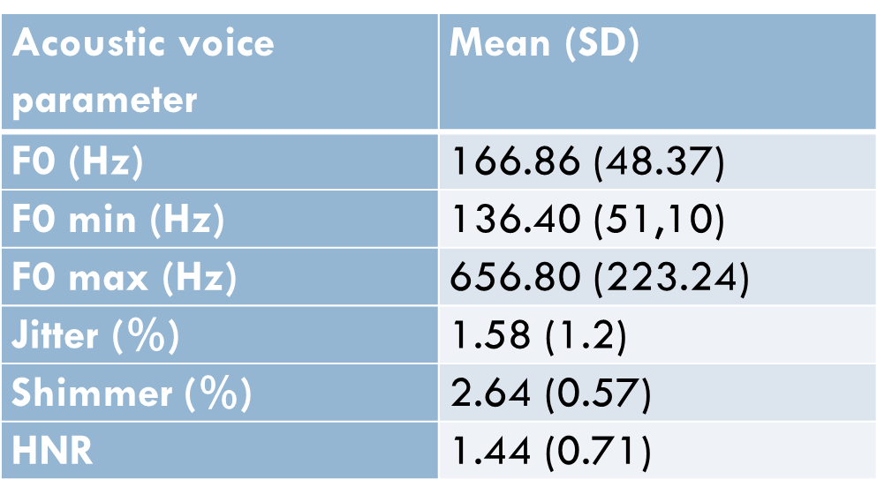

FIGURES

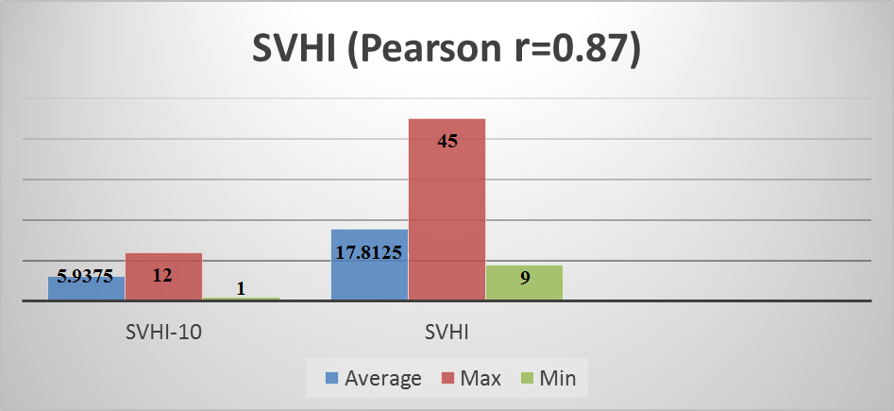
Figure 1. SVHI versus SVHI-10 (Pearson r = 0.87)

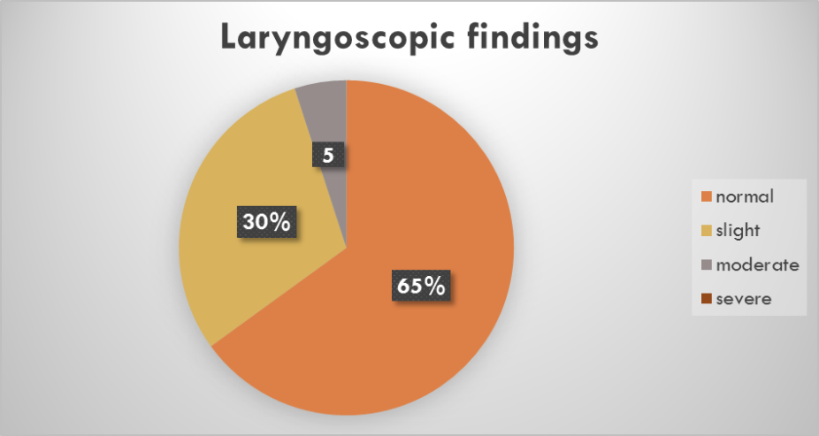
Figure 2. Laryngoscopic findings

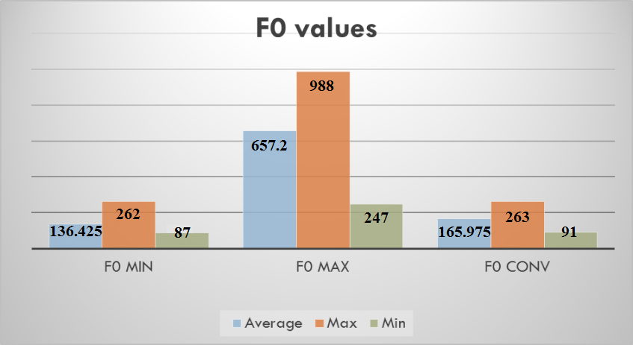
Figure 3. Fundamental frequency

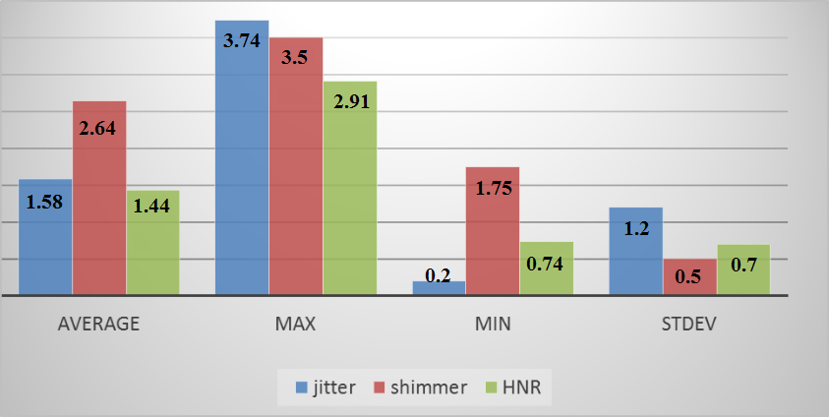
Figure 4. Acoustic analyses

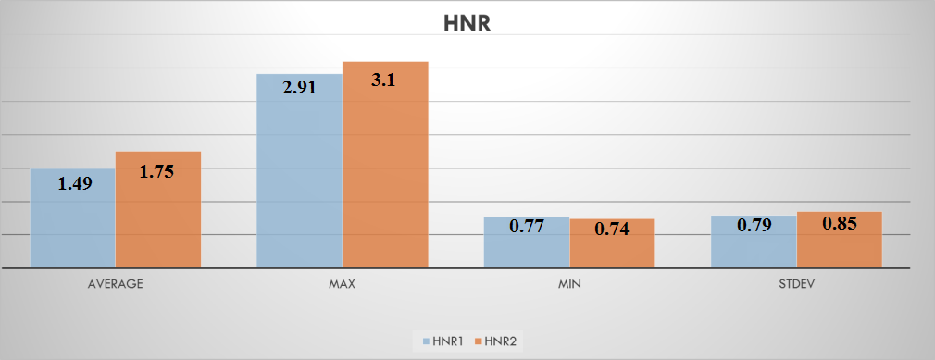
Figure 5. Harmonics to Noise Ratio

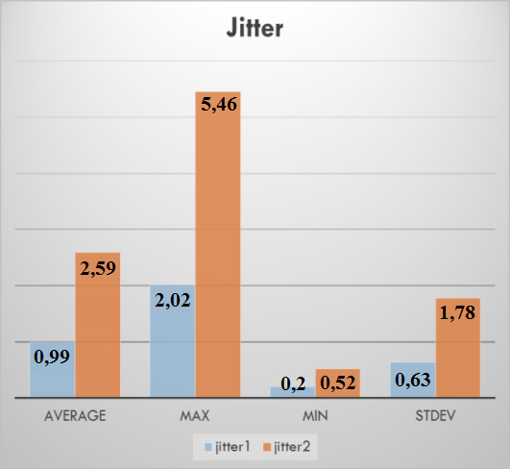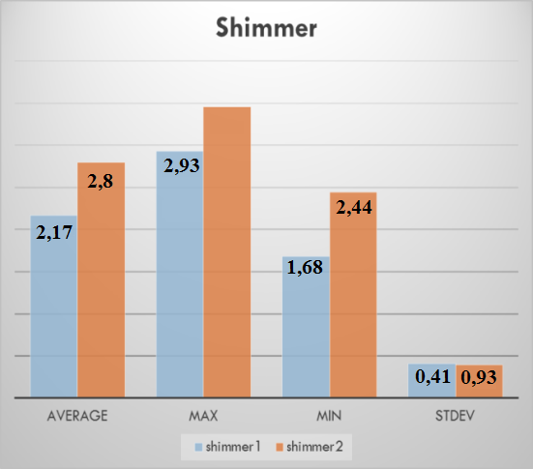
Figure 6. Jitter and Shimmer

